**AI**

**Galaxy Buds2**

SM-R177NZKAMEA

[**Product Ratings :4.2(Number of Ratings :17)**](javascript:void(0))

* Well-balanced Sound
* Battery Life
* ANC

**Looking for alternatives?**

[[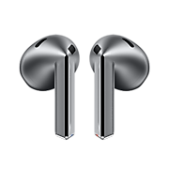](https://www.samsung.com/pk/audio-sound/galaxy-buds/galaxy-buds3-silver-bluetooth-sm-r530nzaamea/)](https://www.samsung.com/pk/audio-sound/galaxy-buds/galaxy-buds3-silver-bluetooth-sm-r530nzaamea/)

[**Galaxy Buds3**](https://www.samsung.com/pk/audio-sound/galaxy-buds/galaxy-buds3-silver-bluetooth-sm-r530nzaamea/)

**Rs. 51,999.00**

[Product Ratings :2.1](https://www.samsung.com/pk/audio-sound/galaxy-buds/galaxy-buds3-silver-bluetooth-sm-r530nzaamea/#reviews)

[**Learn more**](https://www.samsung.com/pk/audio-sound/galaxy-buds/galaxy-buds3-silver-bluetooth-sm-r530nzaamea/)

[[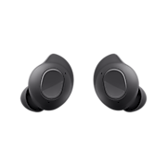](https://www.samsung.com/pk/audio-sound/galaxy-buds/galaxy-buds-fe-graphite-sm-r400nzaamea/)](https://www.samsung.com/pk/audio-sound/galaxy-buds/galaxy-buds-fe-graphite-sm-r400nzaamea/)

[**Galaxy Buds FE**](https://www.samsung.com/pk/audio-sound/galaxy-buds/galaxy-buds-fe-graphite-sm-r400nzaamea/)

**Rs. 33,399.00**

[Product Ratings :4.7](https://www.samsung.com/pk/audio-sound/galaxy-buds/galaxy-buds-fe-graphite-sm-r400nzaamea/#reviews)

[**Learn more**](https://www.samsung.com/pk/audio-sound/galaxy-buds/galaxy-buds-fe-graphite-sm-r400nzaamea/)

**Choose your color**

**Color :**Graphite

* 

**Galaxy Buds2**

Graphite

[**Where to buy**](javascript:;)

**key features**

Well-Balanced Sound

Active Noise Canceling

Comfort Fit

**Galaxy Buds2**

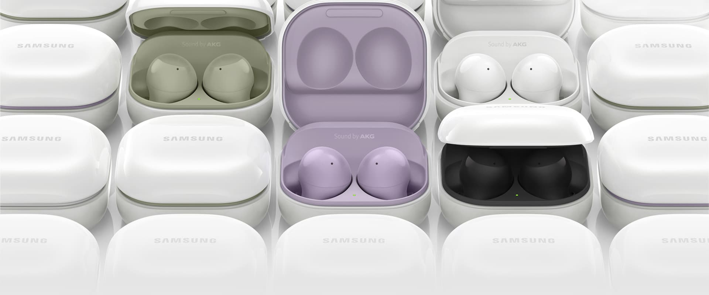

**Immerse yourself  
into your own world**

Get lost in what you love. Galaxy Buds2 opens a new world of audio experience with well-balanced sound, unmatched comfort fit, ANC, and seamless connectivity to your phone and